NOTICE OF REGULAR CITY COUNCIL MEETING
City of Weston Lakes, City Council Meeting
Simonton City Hall 35011 FM 1093 Simonton Texas 77476
Tuesday, April 27, 2010 6:00 pm

AGENDA

- Call to Order.
- Invocation and Pledge of Allegiance
- Public Comment
- Mayors Comments.
  - Census
- Approval of Minutes of the Regular City Council Meeting of MAR 23, 2010.
- Finance.
  - Approval of MAR Treasurer’s Report
  - Approval of transferring funds out of the Election Line into:
    - $3,000 into Engineer’s Budget Line to compensate for the FEMA flood map review
    - $1,000 into MISC Budget Line
    - $1,000 into Membership Fees to cover Greater Fort Bend County Economic Development Council Dues
- Marshal’s Report
- $500 for Fulshear Simonton Weston Lakes Resource Guide
- Drainage District Interlocal Agreement
- Emergency Preparedness Update by Alderman Aldrich
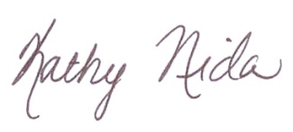
- Adjournment

Kathy Nida
City Secretary

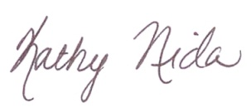
Notice of meeting/agenda posted at the Simonton City Hall, 35011 FM 1093, Simonton, Texas 77476, on (APR 21, 2010 @ 4:45 p.m.).

Signed Kathy Nida________________________________

NOTICE
Policy of Non-Discrimination on the Basis of Disability: The City of Weston Lakes does not discriminate on the basis of disability in the admission or access to, or treatment or employment in, its programs or activities.
NOTICE
The City of Weston Lakes reserves the right to adjourn into executive session at any time during the course of this meeting to discuss any of the matters listed above, as authorized by Texas Government Code Sections 551.071 (Consultation with Attorney), 551.072 (Deliberations about Real Property), 551.073 (Deliberations about Gifts and Donations), 551.074 (Personnel Matters), 551.076 (Deliberations about Security Devices) and 551.086 (Economic Development).

